Home Energy Management System

Needs Analysis and Requirements Specification

**Introduction**

The concept of a viable energy management system is a topic that is gaining momentum on the different economic and social sectors, in which high technological companies are aiming to design a very economic and viable way to control, monitor and manage the energy provided to users and commercial companies. The notion behind a home energy management system relies on the idea of controlling, via user interaction or automatic real time calibration, the different loads present on an average home or a simple SOHO (Small Office/Home Office). This system will benefit users and companies by providing critical information to and from the main energy systems that will allow a full control of the energy usage in the industrial and residential customer’s part of the electrical grid.

**Needs Assessment**

The optimum design of the project is one that will fulfill all the important needs presented by the client (sponsor) and complete all the expectations using top notch technology and the best use of all the resources provided.

In the case of the Home Energy Management System/Controller some of these needs are more essential than others. These needs are presented in the following list.

1. Control of different loads around the space depending on user interface or automatic response.
2. The preferred communication technology between controller and loads is RF/Wireless.
3. Controller must make decisions according to an energy efficiency algorithm that will receive information from real time pricing.
4. System must be energy efficient and have low power consumption.
5. Controller must be in constant communication with the cloud (internet).
6. The algorithm must discern from critical and non-critical loads.
7. If possible, information of power consumption of each load must be provided to the main controller in order to gain important information.
8. Communication link between controller and devices must be reliable and have good distance of action.
9. If possible, an application must be developed in order to give the user a GUI access to the main controller.

Comparison of the essential needs required:

The comparisons will use the Fundamental Scale for Pairwise Comparisons (AHP scale).

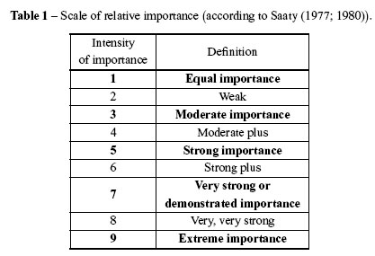

Table1. AHP Scale Table

Needs:

* High Performance
* Low Cost
* Power Consumption
* High Reliability

|  |  |  |  |  |  |  |
| --- | --- | --- | --- | --- | --- | --- |
|  | **High Performance** | **Low Cost** | **Power Consumption** | **High Reliability** | **Geometric Mean** | **Norm. Weight** |
| **High Performance** | 1 | 5 | 5/3 | 1 | 1.70 | 0.36 |
| **Low Cost** | 1/5 | 1 | 1/3 | 1/5 | 0.34 | 0.07 |
| **Power Consumption** | 3/5 | 3 | 1 | 3/4 | 1.08 | 0.23 |
| **High Reliability** | 1 | 5 | 4/3 | 1 | 1.60 | 0.34 |

Table2. Comparison Matrix

According to the information obtained from the sponsor/advisor and using the information derived from the comparison matrix these are the priority in the order of needs to fulfill.

1. High Performance
2. High Reliability
3. Power Consumption
4. Low Cost

**Design Requirements**

In order to fulfill all the needs explained, the project will focus on the next requirements:

1. Control the different loads using MSP432 and nRF24L01P trans-receiver as the communication link.
2. The trans-receiver will use wireless RF/Wireless protocol in order to communicate back and forth with the main controller Beagle Bone Black.
3. An algorithm will be written to control all the loads according to real-time pricing provided by the utility company. Algorithm will process the information and decide which loads can be turn off.
4. The use of microcontrollers and small low energy devices that will be energy efficient and low powered.
5. The Beagle Bone Black (Controller) will be communicating via Ethernet or Wi-Fi with the cloud in order to obtain the settings and most recent information from the utility company.
6. Algorithm must discern, using special settings given by the user, between the critical and non-critical loads.
7. Meters connected to the loads and MSP432 will measure the power consumed by the load and sent back to the controller in order gain important information for decision making.
8. The RF wireless technology used by the Nrf24l01P has a distance between 100 and 400 meters place of action.
9. An Android application or website will be developed in order to control the Beagle Bone Black controller and all the loads connected to the network.

**Acknowledgement of design completion**

If all of the needs and requirements are met the design would be complete. In order for the design to be successful the customer should see a decrease in their monthly electric bill.

**Design Constraints**

Table3. Hardware BOM



As seen above from Table 3, the financial constraint for the project is a budget of $1500.00 which is provided by the Foundations for Engineering Education for Distributed Energy Resources (FEEDERS). Staying within the budget will not be a challenge when compared to the hardship of the actual time the project will take. The hours of work will be distributed amongst the personnel responsible for the completion of the project. See Table 4 and Table 5 for an estimation of the required hours. This estimation is per team personnel, not including the Dr. Omar Faruque, the Senior Design Project Advisor. Between both semesters the estimated time of completion is about 752 hours.

The personnel consists of:

Dillon Wiggins – Electrical Engineering Major

Ivan Remete – Electrical Engineering Major

Pablo Aguirre – Electrical Engineering Major

Juan Ospina – Electrical and Computer Engineering Major

Michael Garcia – Computer Engineering Major

Dr. Omar Faruque – Senior Design Project Advisor

|  |  |  |  |  |  |
| --- | --- | --- | --- | --- | --- |
| **Estimated Hours for the Fall 2015 Semester** | | | | | |
| **Weeks of the Month** | **Fall 2015 Semester Months** | | | | |
| **August** | **September** | **October** | **November** | **December** |
|
| **First Week** | N/A | N/A | 1 | 5 | 10 |
| **Second Week** | N/A | N/A | 5 | 5 | 10 |
| **Third Week** | N/A | 1 | 5 | 5 | 10 |
| **Fourth Week** | 1 | 2 | 5 | 5 | 10 |
| **Total Monthly (Hours)** | 1 | 3 | 16 | 20 | 40 |
|  |  |  |  | **Total**  **Semester Hours** | 80 |

Table4. Estimated Hours required for Fall 2015

|  |  |  |  |  |  |
| --- | --- | --- | --- | --- | --- |
| **Estimated Hours for the Spring 2015 Semester** | | | | | |
| **Weeks of the Month** | **Spring 2015 Semester Months** | | | | |
| **January** | **February** | **March** | **April** | **May** |
|
| **First Week** | N/A | 5 | 7 | 10 | 10 |
| **Second Week** | 5 | 5 | 7 | 10 | N/A |
| **Third Week** | 5 | 5 | 7 | 10 | N/A |
| **Fourth Week** | 5 | 5 | 7 | 10 | N/A |
| **Total Monthly (Hours)** | 15 | 20 | 28 | 40 | 10 |
|  |  |  |  | **Total**  **Semester Hours** | 108 |

Table5. Estimated Hours required for Spring 2015

**Intended application**

Our product is designed to be applied in both residential and commercial settings, in which real time pricing is utilized (by the providing utility). Our product can also be used when a customer desires to control their loads over the network.

**Design composition**

The design will be composed of an algorithm, a main controller, and multiple load controllers. The main controller will communicate with the user via the network and will send and receive data from the load controllers while obtaining real time pricing from the utility synchronously.

The load controllers have the function of gathering the data form the loads (watt hour), controlling the loads, and sending/receiving data to the main controller.

With this system, the user will be able to determine the hierarchy of the loads from a device that connects to the network (Smartphone, computer, etc.). Based on the hierarchy of the loads, the main controller will send and receive data from the load controllers, where an algorithm in the main controller will control the loads based on the real time pricing and the user’s preference.

**Hardware**

Main controller between network and all loads is the BeagleBone. In order to connect to the network the BeagleBone will utilize Ethernet. Load controllers will be MSP432P401R LaunchPads, the MSP432s will communicate with the BeagleBone via an nRF24L01+ 2.4GHz Wireless Transceiver. **(See figure 1)**

**Technologies required for the design**

* Network (cloud storage)
* Microcontrollers
* RF Transceivers
* Relays
* Sensors

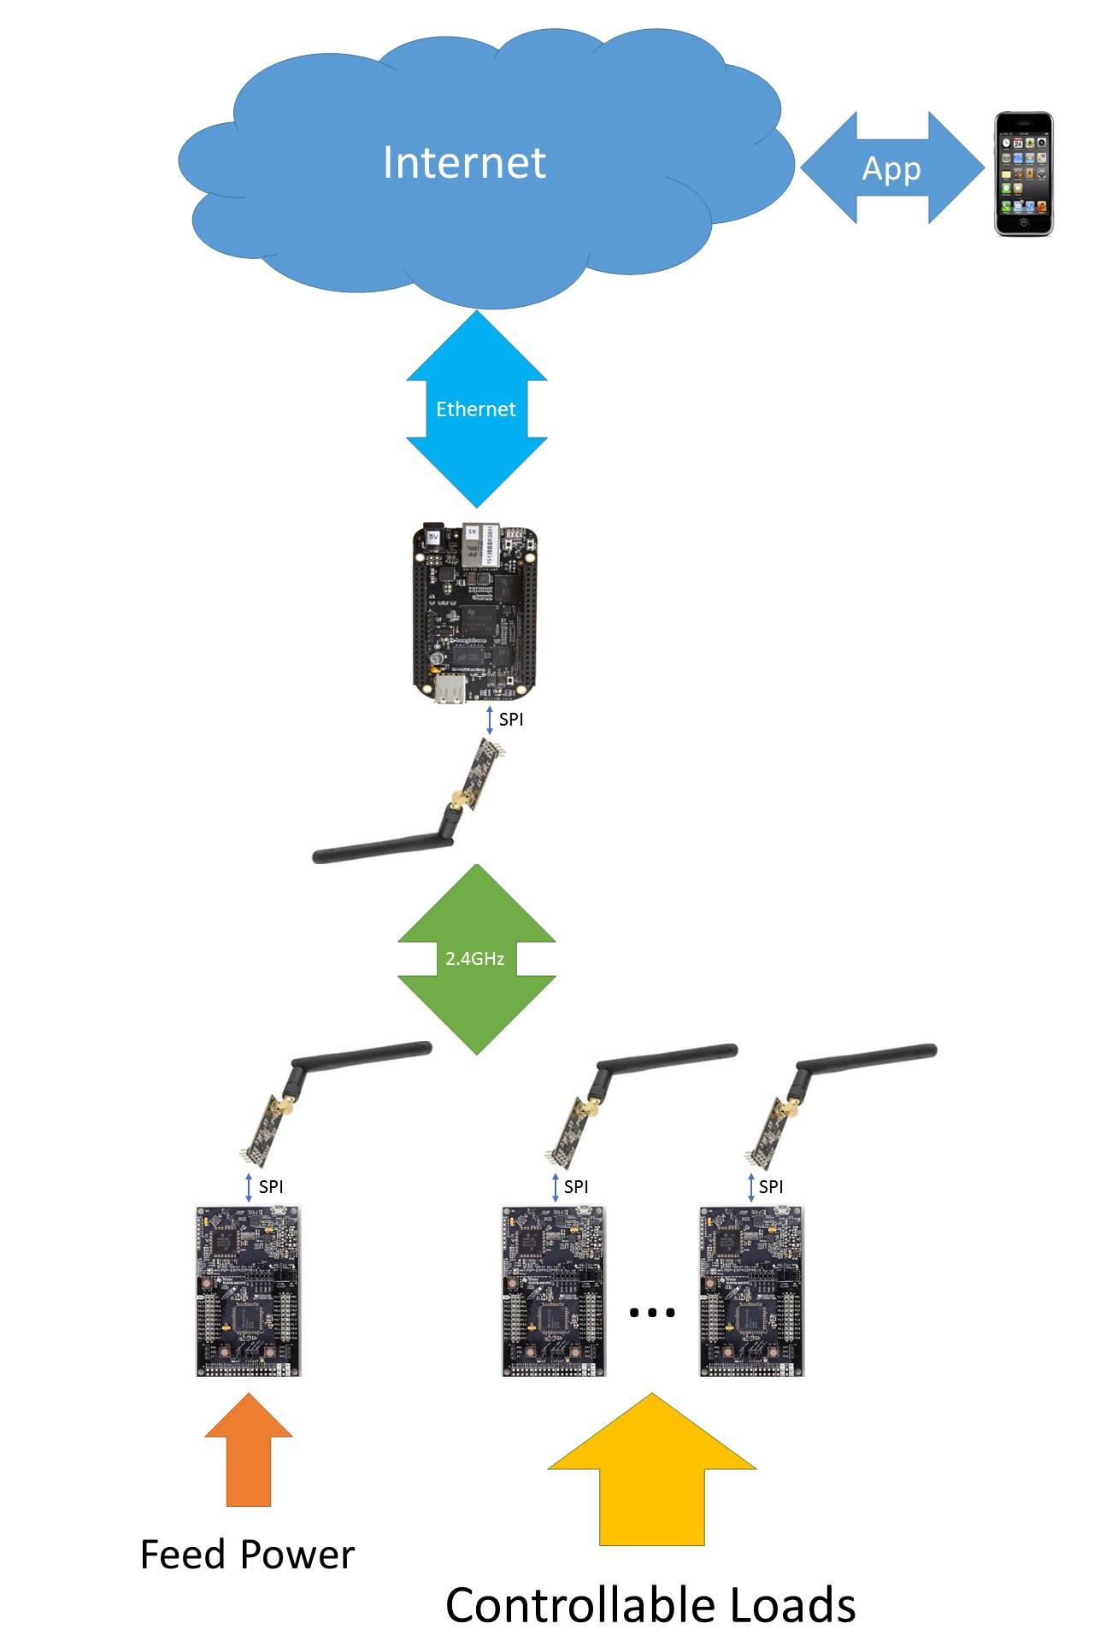

Figure1. Network Diagram

**Possible Extras/Additional Applications**

The design could lead us to develop important aspects that the systems will require in order to be a possible realizable product ready for the market. These are some optional features the client has pointed out for the design proposed.

1. User Application: The development of an Android/iOS user application that will allow the user to control all the parts of the system developed. In essence, the application should user friendly and let the user control all the loads in his own environment. Also, making lists critical and non-critical loads and changing other settings just by accessing the application from any place with internet connection.
2. Security: A system with this total control over important loads needs to have strong and reliable security protocols to protect intruders from accessing and controlling the information generated from the devices connected to the network controller. A design of a security mesh could be implemented to solve this possible problem of implementation.